Foundation | Year 1 | Year 2 | Year 3 | Year 4 | Year 5 | Year 6
  Baking biscuits for Grandparents Afternoon Tea event | Visitors from St Phillips centre – faith assemblies | Visitors from St Phillips centre – faith assemblies | Schools Linking project  Bosworth Battlefield visit |   Wombling and ECO Ambassadors | Sports Ambassador  Playground buddies | Takeover day  £5 challenge
Make a model from recycled materials | How should we care for the world and others? | Taking care of the Earth. | How and why do people make the world a better place? | My Online life – computing | Experience life in a Victorian Mill | DAaRT program    Make do and mend textile work
Visit to Leicester Cathedral  Diwali celebrations |   Lambing visit |   Astronomy | Poems around our senses | Persuasive writing about ‘Who let the Gods out?’ |   Investigate a river and sketch in a contrasting locality | Bollywood dancing
Perform in front of an audience (Nativity)  Watch a theatre production | Watch a theatre production    Spend time in our local library | Perform in front of an audience (Christmas)  Watch a theatre performance |   Watch a theatre performance  Caribbean instrument music unit | South African Instrumental music unit  Watch a theatre production | Watch a theatre production  Egyptian theme composition and notation unit | Perform in front of an audience (leavers play)  Watch a theatre production

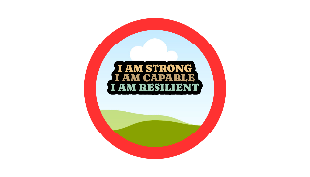

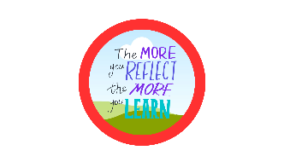



SOCIAL
Contribute to a diverse society and co-operate with others
MORAL
Investigate ethical issues and show awareness of different perspectives
SPIRITUAL
Awe and wonder of the natural world and reflection of own experiences
CULTURAL
Appreciate and participate in artistic, musical and sporting opportunities

Curriculum opportunities and visits to embed SMSC

